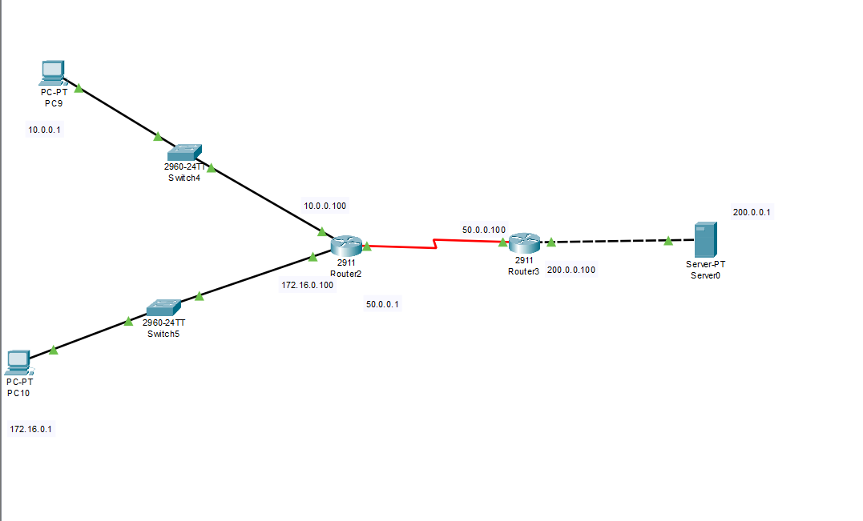

**Static**

ROUTER 0:

Router(config-if)#exit

Router(config)#int g0/0

Router(config-if)#

Router(config-if)#ip nat inside

Router(config-if)#int se0/1/0

Router(config-if)#ip nat outside

Router(config-if)#exit

Router(config)#ip nat inside source static 10.0.0.1 60.0.0.1

Router#Wr

Router#conf t

Enter configuration commands, one per line. End with CNTL/Z.

Router(config)#ip route 200.0.0.0 255.255.255.0 50.0.0.2

Router(config)#exit

Router 1:

Router(config)#ip route 60.0.0.0 255.0.0.0 50.0.0.1

**Dynamic:**

Router0:

Router(config-if)#ip address 172.16.0.100 255.255.0.0

Router(config-if)#

Router(config-if)#exit

Router(config)#int g0/1

Router(config-if)#ip nat inside

Router(config-if)#exit

Router(config)#int se0/1/0

Router(config-if)#ip nat outside

Router(config-if)#exit

Router(config)#access-list 10 permit 172.16.0.0 0.0.0.255

Router(config)#ip nat pool DNAT 70.0.0.1 70.0.0.5 netmask 255.0.0.0

Router(config)#ip nat inside

% Incomplete command.

Router(config)#ip nat inside source list 10 pool DNAT

Router(config)#exit

Router1:

Router>en

Router#conf t

Enter configuration commands, one per line. End with CNTL/Z.

Router(config)#ip route 70.0.0.0 255.0.0.0 50.0.0.1

Router(config)#exit

Router#

%SYS-5-CONFIG_I: Configured from console by console

Router#wr

Building configuration...